Special educational needs (SEN) and disabilities Policy

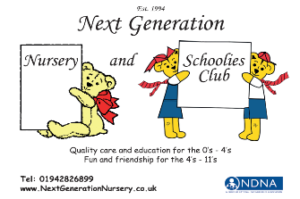

This policy is used and underpinned by the Special Educational Needs and Disability Code of Practice that was published in June 2014 with updates occurring accordingly – latest update April 2020. Available online.

Hard copies of the code can be purchased from NDNA.

Here at the Next Generation nursery we are committed to the inclusion of all children. All children have the right to be cared for and educated to achieve the best possible outcomes, to share opportunities and experiences and develop and learn alongside their peers. We provide a positive and welcoming environment where children are supported according to their individual needs.

We recognise that some children may have additional needs that may require targeted help, intervention and support. These needs may be short-lived for a particular time in the child’s life or may require longer-term or lifelong support. At all times we will work alongside each child’s parents and any relevant professionals to share information, identify needs and help the child and their family access the support they need.

In accordance with our admissions policy, we are committed to providing a childcare place, wherever possible, for children who may have special educational needs (SEN) and/or disabilities according to their individual circumstances, and the nursery’s ability to make any reasonable adjustments in order to provide the necessary standard of care. All children will be given a full settling in period when joining the nursery according to their individual needs.

Where we believe a child may have learning difficulties and/or a disability that has not previously been acknowledged, we will work closely with the child’s parents and any relevant professionals to establish the child’s needs and to secure any action that may be required. We recognise that children with disabilities may not have SEN but may need the nursery to make reasonable adjustments to enable them to make full use of the nursery’s facilities.

Where we have emerging concerns about a child and/or where a child has identified additional needs or a disability, we will find out as much as possible about the needs of the child and any support the child or family may need to ensure the child makes the best progress in their learning and development. We do this by:
- Following our ‘Assess, Plan, Do, Review’ process in-line with the Wigan Council Graduated Approach for SEND
- Liaising with the child’s parents to gain their views and input as well as providing them with strategies to support at home
- Observing each child’s development and monitoring such observations regularly
- Liaising with any other relevant professionals engaged with the child and their family
- Seeking any specialist help or support
- Researching relevant publications/sources of help
- Reading any reports that have been prepared
- Attending any assessment or review meetings with the local authority/professionals.

Legal framework and definitions

The relevant legislation underpinning this policy includes:
- Special Educational Needs and disability Code of Practice: 0 to 25 years
- The Children and Families Act 2014, Part 3
- The Equality Act 2010
- Special Educational Needs and Disability Regulations 2014
- Statutory Framework for the Early Years Foundation Stage September 2021
- Working together to Safeguard children 2018

We use the definitions set out in the law to describe SEN and disabilities. (SEND)
- A child has SEND if they have a learning difficulty or disability which calls for special educational provision to be made for them.

- A learning difficulty or disability means that a child of compulsory school age has a significantly greater difficulty in learning than the majority of other children of the same age; and/or has a disability which prevents or hinders them from making use of the sort of facilities generally provided for others of the same age.

- For children aged two or more, special educational provision is educational provision that is additional to or different from that made generally for other children of the same age. For a child under two years of age, special educational provision means educational provision of any kind.

- A child under compulsory school age has SEND if he or she is likely to have a learning difficulty or disability when they reach compulsory school age or would do so if special educational provision was not made for them.

- A disability is defined in the Equality Act 2010 as ‘a physical or mental impairment which has a long-term and substantial adverse effect on their ability to carry out normal day-to-day activities’. ‘Long-term’ is defined as ‘a year or more’ and ‘substantial’ is defined as ‘more than minor or trivial’. This definition includes sensory impairments such as those affecting sight or hearing, and long-term health conditions such as asthma, diabetes, epilepsy, and cancer. Children with such conditions do not necessarily have SEND, but there is a significant overlap between disabled children and those with SEND. Where a disabled child requires special educational provision they are also be covered by the SEND definition.

Aims

The nursery has regard to the statutory guidance set out in the Special Educational Needs and Disability Code of Practice: 0 to 25 years (2020). We have clear arrangements in place to support children with SEN and disabilities. We aim to:
- Recognise each child’s individual needs through gathering information from parents and others involved with the child on admission and through our procedures for observation and assessment
- Ensure all staff understand their responsibilities to children with SEN and disabilities and have regard to the guidance given in the Special Educational Needs and Disability Code of Practice 2020.
- Plan, provide or help parents to obtain any additional help or support for any needs not being met by the universal service provided by the nursery
- Include all children and their families in our provision, making reasonable adjustments where needed
- Provide well-informed and suitably trained practitioners to help support parents and children with special educational needs and/or disabilities
- Identify any emerging concerns that might suggest a child has special educational needs and/or disabilities at the earliest opportunity and plan for those needs through a range of strategies
- Share any information received and assessments made by the nursery with parents and support parents in seeking any help they or the child may need
- Seek any additional help needed including requesting an Education, Health and Care (EHC) Needs Assessment where the nursery’s own actions are not helping the child to make progress
- Work in partnership with parents and other agencies in order to meet the individual children's needs, including health services and the local authority, and seek advice, support and training where required
- Monitor and review our practice and provision and, if necessary, make adjustments and seek specialist equipment and services if needed
- Ensure that all children are treated as individuals/equals and are encouraged to take part in every aspect of the nursery day according to their individual needs and abilities
- Ensure that gifted and talented children who learn more quickly are also supported
- Encourage children to value and respect others
- Challenge inappropriate attitudes and practices
- Promote positive images and role models during play experiences of those with additional needs wherever possible
- Celebrate diversity in all aspects of play and learning.

Methods

We will:
- Develop and maintain a core team of staff who are experienced in the care of children with additional needs. Staff will be provided with specific training to help them make any special educational provision needed and meet the requirements of the Special Educational Needs and Disability Code of Practice 2020
- Identify a member of staff to be our Special Educational Needs Co-ordinator (SENCO) and share their name with parents (see below for an explanation of their role). Appoint a deputy SENCO to support and cover this role in absence.
- Ensure that the provision for children with learning difficulties and/or disabilities is the responsibility of all members of staff in the nursery.
- Ensure that our inclusive admissions practice includes equality of access and opportunity
- Ensure that our physical environment is, as far as possible, suitable for children and adults with disabilities. With changes being made as necessary to support further.
- Work closely with parents to create and maintain a positive partnership which supports their child(ren) – offering an Early Help assessment/meeting.
- Provide differentiated activities to meet all individual needs and abilities to give a broad and balanced early learning environment for all children including those with learning difficulties and/or disabilities
- Ensure that parents are consulted with and kept informed at all stages of the assessment, planning, provision and review of their child's care and education, including seeking any specialist advice
- Ensure that children’s views are sought and listened to
- Use a graduated approach (see explanation below) to identifying, assessing and responding to children who have emerging difficulties, suggesting they may have special educational needs or a disability that requires a different approach
- To liaise with Wigan’s Early Learning and Childcare team (ELCC) / Inclusion team, with parental consent obtained, to notify them of any concerns we may have regarding a child’s needs/abilities. They will then work alongside us in ensuring we are supporting the child effectively and will also advise us on what to do next to meet the needs of the child.
- When planning interventions and support, agree the outcomes and the expected impact on progress and a date for review
- Hold review meetings with parents at the agreed times and agree any changes or adjustments to support – usually termly to give time for progress and embedding of support.
- Seek any further advice or support needed including multi-agency approaches, Early Support and requesting an Education, Health and Care (EHC) Needs Assessment where targets and actions are not helping the child make a good level of appropriate progress.
- Liaise with other professionals involved with children with learning difficulties and/or disabilities and their families, including transfer arrangements to other settings and schools. We work closely with the next school or care setting and meet with them to discuss the child’s needs to ensure information exchange and continuity of care
- Provide parents with information on sources of independent advice and support – ensuring that they understand all processes and the involvement of such agencies throughout.
- Keep records of the assessment, planning, provision and review for children with learning difficulties and/or disabilities
- Provide resources, in so far as we can (human and financial), to implement our SEN/disability policy
- Ensure the privacy of children with learning difficulties and/or disabilities when intimate care is being provided
- Provide in-service training for practitioners and volunteers as well as accessing what is available within our local authority.
- Raise awareness of any specialism the setting has to offer, e.g. Signalong trained staff, EYPDP trained staff, Keys to Communication trained staff
- Ensure the effectiveness of our SEN/disability provision by collecting information from a range of sources e.g. assessment information, targeted plans and outcomes, staff and management meetings, parental and external agencies’ views, inspections and complaints. This information is collated, evaluated and reviewed annually
- Monitor and review our policy annually making ongoing changes as neccessary

The role of the Special Education Needs and Disability Co-ordinator (SEND-CO)

The role of the SEND-CO is to provide a lead for staff in relation to SEN and disabilities and to make sure procedures are followed, appropriate records kept and parents are involved. The child’s practitioner (key person) will normally remain responsible for working with the child on a daily basis and for planning and delivering an individualised programme. The particular responsibilities of our SEND-CO are:
- ensuring all practitioners in the setting understand their responsibilities to children with SEND and the setting’s approach to identifying and meeting SEND
- advising and supporting colleagues
- ensuring parents are closely involved throughout and that their insights inform action taken by the setting
- liaising with professionals or agencies beyond the setting.

Our nursery SEND-CO is Zoe Morgan and our deputy SEND-CO is Nicola Hilton.

Graduated approach –

In line with requirements of the Special Educational Needs and Disability Code of Practice, we take a graduated approach to working with children with emerging concerns and their families. This approach includes:
- An analysis of the child’s needs including whether we should seek more specialist help from health, social services or other agencies
- An agreement about the interventions and support needed and the expected impact on progress and a date for review
- Implementation of the interventions or programmes agreed, including assessing the child’s response to the action taken
- A review of the effectiveness of the support and its impact on the child’s progress by the key person, SENCO, the child’s parent(s) and the views of the child, including any agreed changes to outcomes and support
- Revisiting this cycle of action in increasing detail and frequency including seeking further specialist help to secure good progress until the SENCO, key person, the child’s parent(s) and any other professionals involved agree intervention is no longer needed or decide to request an education, health and care needs assessment (see below).

Nursery will aim to follow the ‘assess, plan, do, review’ cycle to continually support the child and their family.
Below are the 5 tables that provide us with a route to go down and what approach we need to take as a setting to best support the child and family identified.

The Graduated Approach – Wigan Council Local Authority Inclusion Team

Below is a table that outlines the involvement and support of the Wigan Early Years Inclusion Team in identifying and supporting a child with SEND. The second bubble refers to the setting having already put in place ‘Additional to Focused’ support before this flowchart is utilised. Beneath the Graduated Approach flowchart, please also see ‘”A child centred approach” which also forms part of the Graduated Approach but details the support that we will offer and maintain until it is necessary to involve the ELCC Inclusion team for further guidance, support and/or funding as necessary as per flow chart.

Wigan Graduated Approach Flow Chart
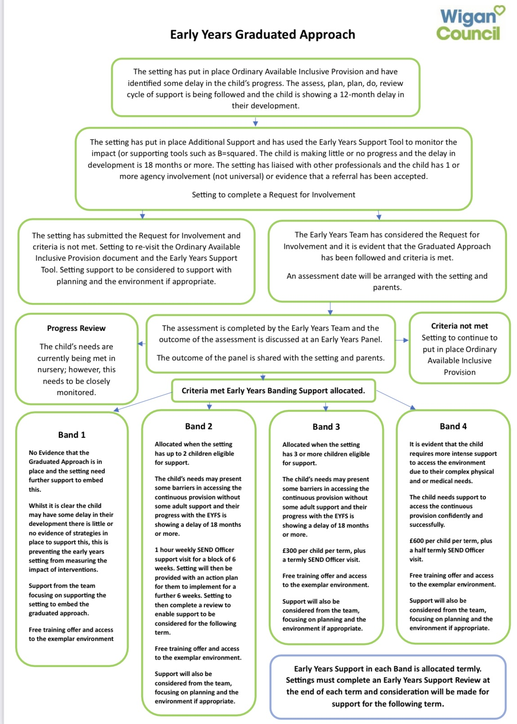

A Child Centred Approach – The Graduated Approach
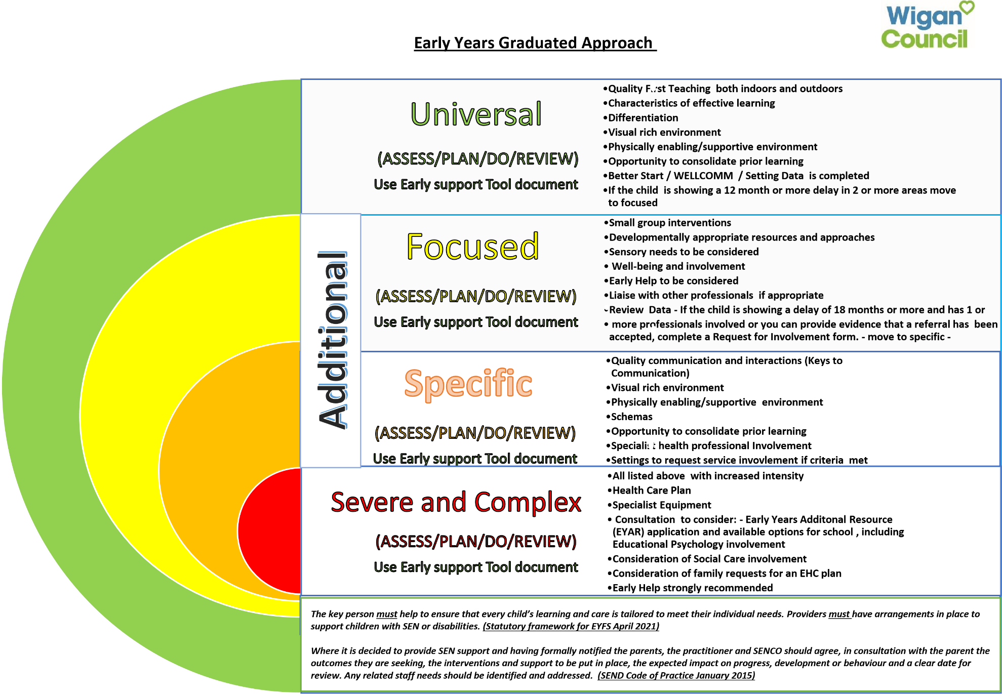

Planning, Differentiation, smalls groups and strategies – Key persons will ensure that children’s needs are initially supported through the way in which they plan for the child and differentiate the activities and experiences to their level of learning in order for them to make progress. Key persons will also ensure that children are supported by an adult through small group interventions should they feel that a child is showing an apparent/emerging need. Giving children more specific and targeted time in smaller groups with an adult will allow the adult to give more direct support and teaching but will also give the practitioner the ability to see and monitor progress with the repetition of such small groups over time, as to whether strategies used within these groups are helping the child to progress. The strategies that practitioners will use in these small group interventions will be tailored to what the child/children need. These may vary from Keys to Communication strategies, EYPDP strategies to more specific targeted strategies such as ‘The box’ – The key person may liaise with the SENCO to ensure they are accessing the most appropriate strategies for the child/children. Progress will be monitored throughout and parents/carers will be continually updated. Key persons will ensure they are referring to the above ‘A child Centred approach’ throughout.

WellComm

WellComm is defined by GL assessment as “A speech and language toolkit used by early years and primary practitioners, such as nursery workers, health visitors and teachers, to identify any speech and language difficulties quickly and easily, in early years and primary school pupils, so that appropriate support can be provided.”

At Next Generation, all children are assessed using the WellComm toolkit as part of their settling in/baseline assessment period by one of our WellComm leads. At present, Nicola Hilton takes the lead with this. Nicola is our Early Years lead who has attended the WellComm training along with Zoe Morgan (Manager), Tom Noonan (Deputy Manager), Teigan Archer (Senior practitioner) and Rebecca Crusham (Senior practitioner).
Children are assessed with regards to their speech, language and communication skills by sitting through an assessment with one of the above staff members on a one-to-one basis. The child is assessed in line with their age and scores either Red, Amber or Green. This Red, Amber or Green outcome determines the next steps for the child and the setting with regards to the level of support they need as a result.
Green indicates language development is at the level it should be.
Amber requires us to repeat the screening process using the score sheets from the age band below until the child achieves a green score. This then determines the level the child is working at.
Red requires a repeat screening process using score sheets from the age bands below until the child achieves a green score – If a child is having significant difficulties we will use our judgement to decide which section to screen at that we feel is best suited to the children.
Children are then reviewed every 8-12 weeks depending on the outcome of their assessment.
The WellComm tool kit also supports home learning and ‘homework’ is sent home by the key person at the section that is above the green score e.g. if a green score is achieved at section 2, staff and families will be working on activities from the ‘Big Book of Ideas’ level 3 and so on.

2 Year Integrated review – As part of the EYFS requirements, Early Years settings are obliged to assess each child’s progress between the ages of 2 to 3. This should be done as a joint assessment between the child’s key person, the child’s family health visitor and the child’s parents, where it is possible, to gain a holistic view of the child. Practitioners must provide parents with a short summary of their child’s progress and abilities along with detailing their next steps/targets for future progression. The EYFS requirements state:

“When a child is aged between two and three, practitioners must review their progress, and provide parents and/or carers with a short written summary of their child’s development in the prime areas. This progress check must identify the child’s strengths, and any areas where the child’s progress is less than expected. If there are significant emerging concerns, or an identified special educational need or disability, practitioners should develop a targeted plan to support the child’s future learning and development involving parents and/or carers and other professionals (for example, the provider’s Special Educational Needs Co-ordinator (SENCO) or health professionals) as appropriate.”

Data submission/Better Start – As part of our in-house curriculum and planning systems, we assess each child’s progress towards the end of each academic term and we submit this data to Wigan Local Authority through an online secure system. From we this we can look at whole setting progress all in one place, we can unpick patterns in development and progress/lack of progress for groups of children and much more. This gives us a basis for setting ourselves room and whole setting targets to improve and help children progress further.

Termly reviews and/or Earliest/Early Help

Should a child within setting be being supported additionally to those children alongside them, we will meet with parents each term to review progress and next steps. This will usually be done with the child’s key person but may also involve the setting SENCO dependent upon the involvement of further agencies. During such meetings we will share all that we have been doing over the term, we will liaise with parents about home life and progress within the home and we will work together with parents to derive next steps that will be covered over the following term. When children have apparent and/or emerging needs and therefore have a multi-agency team supporting them, such as health, speech and language therapy or occupational therapy, we may then open an ‘Early Help’ for the family to bring all agencies together in one place to support the family best. A lead professional would be appointed to lead the meetings and to correlate information shared into a report for all to read and have sight of ongoing. Parents must consent to having an Early Help assessment carried out. Assessments will need to be submitted to the ‘Early Help Hub’ online as a data storing confidential system. This also allows for other agencies to refer to the Early help should they need to. Early helps assessments can be offered in-house to a family at any time, regardless of multi-agency involvement, to help support the family to the best of our ability.

Education, Health and Care (EHC) Needs Assessment and Plan –

If the help given through the nursery’s graduated approach is not sufficient to enable the child to make satisfactory progress, we may request, in consultation with the parents and any external agencies already involved, an assessment of the child’s needs by the local authority. This is called an Education, Health and Care (EHC) assessment. The assessment will decide whether a child needs an EHC assessment plan. This plan sets out in detail the education, health and social care support that is to be provided to a child who has SEN or a disability. The local authority will consult with parents and let them know the outcome of the assessment.
We will see through Early Years Additional Resources assessments for children that attend nursery with diagnosed and confirmed needs, who have funding and support in place by the Local Authority Inclusion team, and are due to transition to school. Whether this be mainstream or specialist provision. This is a multi-agency process but we will work closely with parents to ensure that this is seen through to gain support for the child in school longer-term. This EYAR process can then naturally lead onto the child’s Education, Health and Care plan should their needs determine that their support will need to be long term. The local authority will co-ordinate this with multi-agency involvement.

Threshold of need and Early Help
The Wigan Thresholds of need indictor has been designed in support of ‘Working together to safeguard children’ and states that “It is designed to help identify when a threshold – or trigger – has been reached, indicating when a child, young person or family might need support and then to identify where best to get this support from”. Each level of the Threshold of need is explained below. This allows us to identify at what level the support is needed dependent upon the child’s need to best safeguard and protect that child and family, as well as the actions needing to be taken.

- Level 1 – Universal: Most children will have their needs met through universal provision. At this level, services are ‘universal’ meaning that they are available to all children and young people. Families and young people can use these services without the need for a referral or assessment. For example: GP, Children’s centres, libraries, leisure centres and health services.

- Level 2 – Earliest Help (Additional Needs): For some children and families, help is required to respond to a specific need that cannot be met solely through universal provision. This may include: specialist speech and language services, a specific health need, a temporary response to an event, i.e. Bereavement, eviction/homelessness, school non-attendance etc. This is often a single agency response. An Early Help assessment and plan is needed to co-ordinate a SMART response for the child and family.

- Level 3 – Early Help (Complex Needs): Some families have multiple needs and wont achieve positive outcomes without co-ordinated support from a number of agencies led by one professional. Help can be achieved by using a multi-agency ‘Team Around the Family’ (TAF) approach within the Early Help Framework. An Early Help assessment and plan is needed to co-ordinate a SMART response for the child and family. Families requiring support at this level may require specific support from Children’s Services via Start Well.

- Level 4 – Safeguarding Acute and Specialist: Some children, young people and their families will require more specialist social work to ensure they can achieve their full potential. Without this help and support their health and development may be significantly impaired. This includes children who may have a disability. These are referred to as ‘Children in need’. Some children will need social work support to protect them from significant harm. This can be to prevent harm or as a response when harm has already occurred. A small number of children and young people will require statutory interventions from the Targeted Youth Support Service. Other children who have been deemed to be at risk of significant harm at child protection or child in need level will be identified at level 4.

A record of this will be kept to show which children are identified at which level and the support they are receiving by the Manager/DSL/SENCO.

In the event of a pandemic/nursery closures –
Should there be any periods of closures for us as a setting for matters such as a global pandemic, a physical matter with the building restricting children’s attendance or any unexpected closure of the nursery then the DSL/SENCO/Nursery manager will work with the local authority in keeping in contact with vulnerable children and their families to ensure that ongoing support is given. This may mean that the DSL/SENCO and/or management may need to take home the nursery mobile or contact details for families in order to do so. Details taken will remain confidential to the staff member only and will not be shared amongst further family of the staff member and the SENCO/DSL/Manager who is contacting will ensure that this is done in a quiet, confidential space within the home and that notes will be made of any discussions for our records. Any records made will be stored accordingly in the child’s SEN or Child protection individual file. Home learning activities will be provided and promoted to ensure the child receives ongoing support. The nursery will endeavour to resume education as soon as possible in the event of such closures and will follow any local authority or government advice in doing so.

Local offer – The local offer is defined by Wigan Local Authority Council as:

“The Local Offer is all the provision we expect to be available across education, health and social care for children and young people in Wigan Borough who have SEN or are disabled, including those who do not have Education, Health and Care (EHC) plans.”
It’s key aims are to Provide clear, comprehensive, accessible and up to date information on services available and how to access them and to ensure services are more responsive to local needs and aspirations by directly involving children and young people with SEND and their parents, as well as professionals, in its development and review. The site can be accessed by all including parents, families and professionals to gain access to the services available across Wigan. This applies to all children with SEN up to the age of 25years an beyond.
The local offer can be found at SEND Local Offer (wigan.gov.uk)
We will aim to work with families in accessing this site should they need the support to find what they are looking for, to find out what is available to them and more. This will be promoted to all of our families of children with SEN and/or Disability.

High Expectations For All –
The HEFA guidance is to be used alongside the Special Educational Needs and Disability Code of Practice: 0 to 25 Years (January 2015).
It sets out information about the provision the Local Authority expects to be available across education, health and social care for children and young people who have SEN or are disabled, including those who do not have Education, Health and Care (EHC) plans.
It has been drawn up by education, health and care professionals, multi-disciplinary working groups (including parents and representatives from the voluntary and community sector) and will be updated over the coming years as development and review occur.
Section 12 of the HEFA outlines the Early Years Pathway that we must have reference to in support our children who have emerging or diagnosed SEND. This sections makes reference to and guides us through elements such as the Graduated approach, early intervention and transitions to school and the processes to follow.

Policy created by Zoe Morgan 25/4/2023

To be reviewed 24/4/2024

Review table
Date of review | By who | Overview of changes made
Reviewed 30.10.23 | Zoe Morgan | Changed Graduated Approach

